8-31-2006
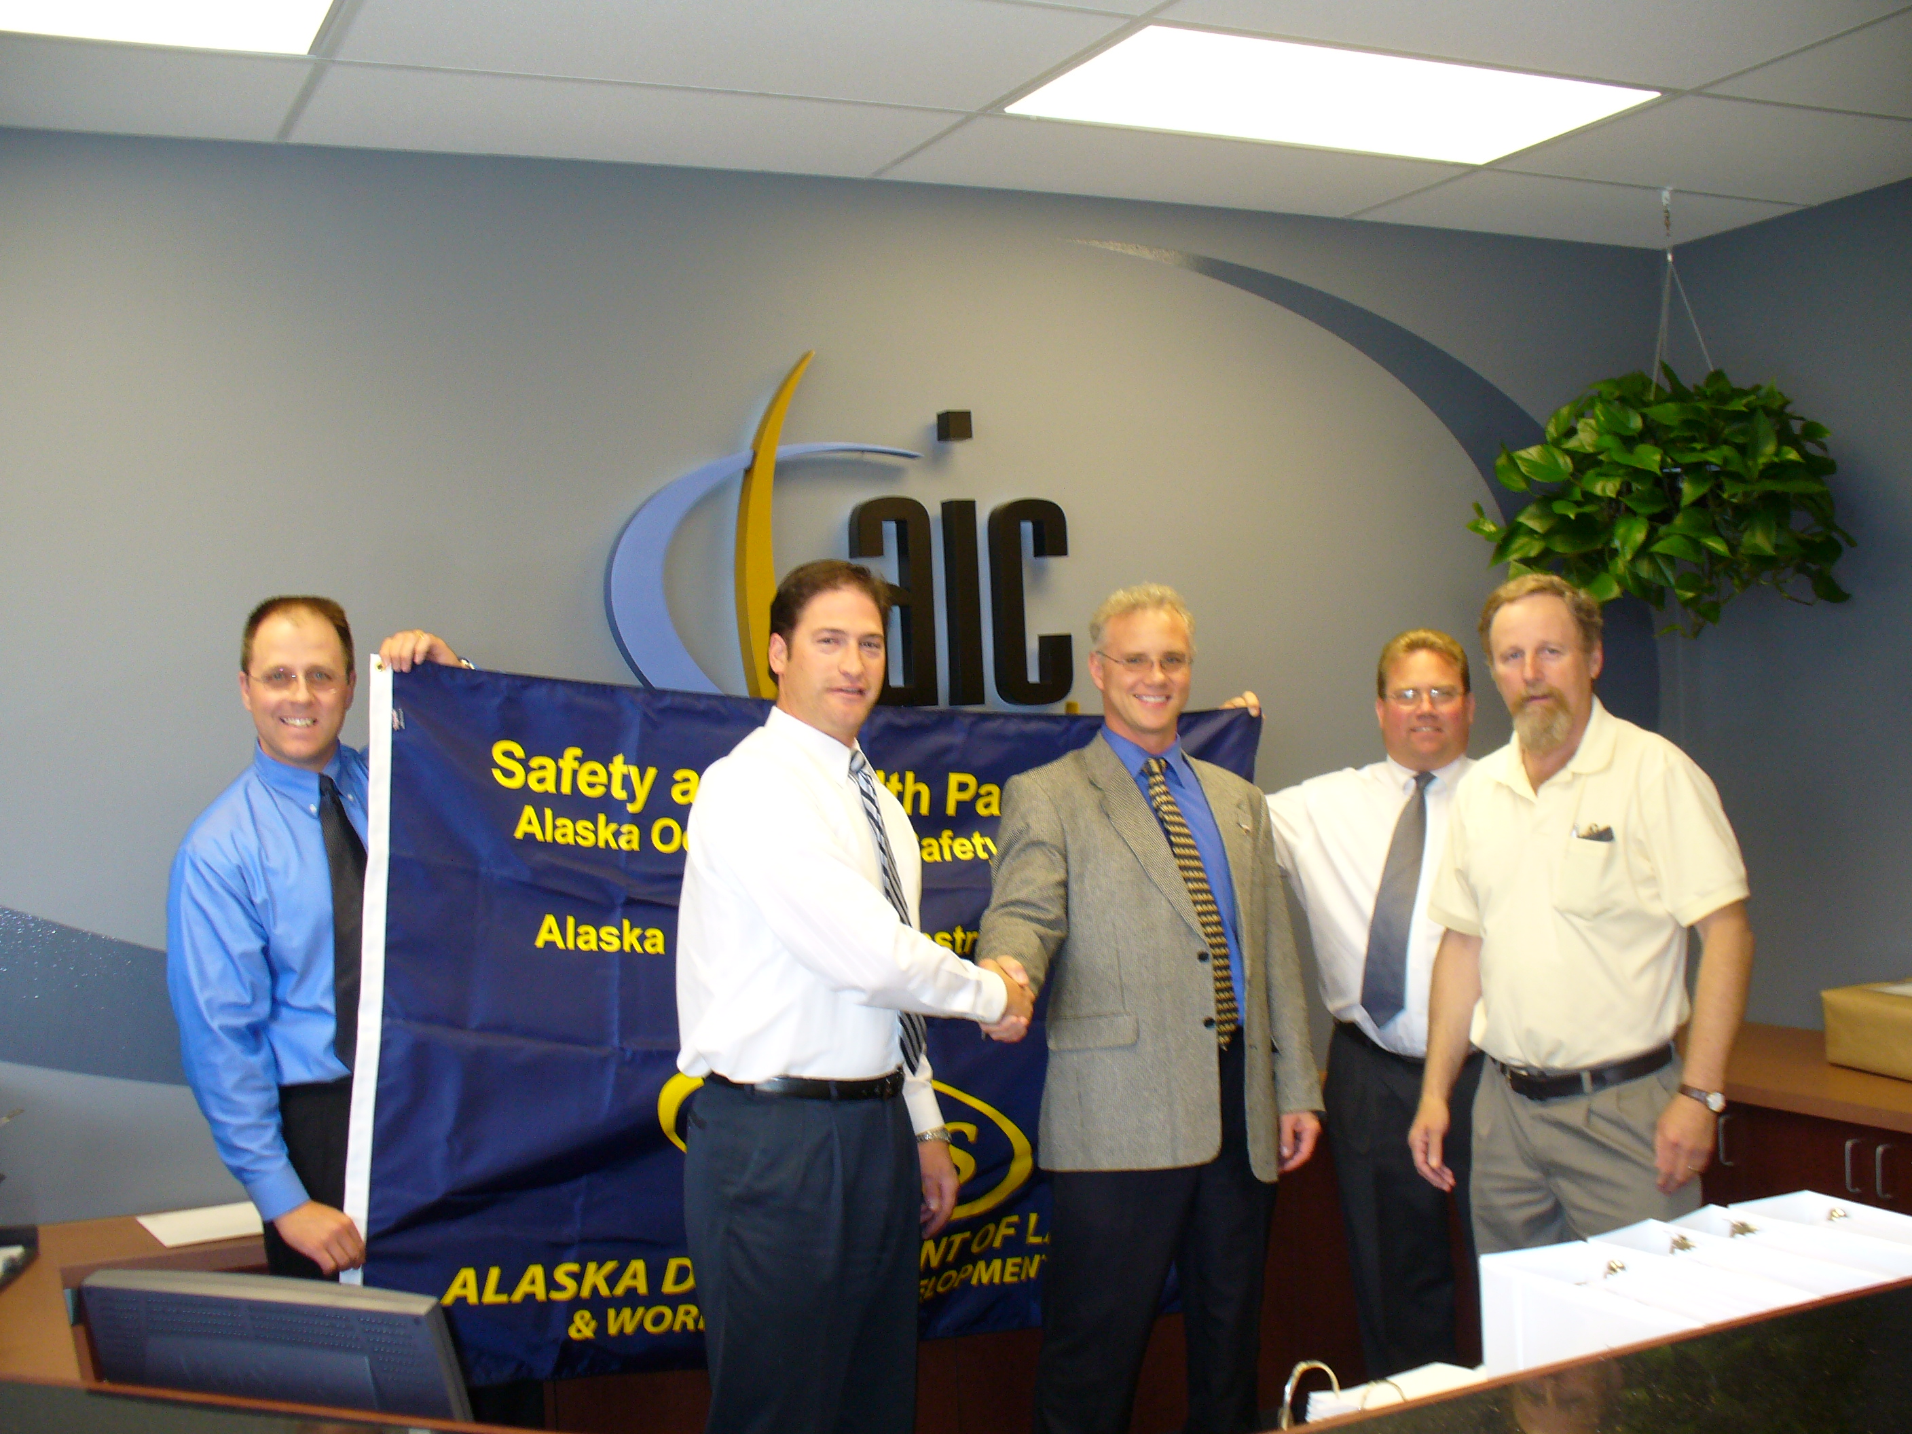
AIC has been described by the Alaska Department of Workforce Development as the “Flagship for Safety in the Construction Industry.” We’ve made it our corporate goal to do whatever it takes to ensure that personal safety is maintained on all of our jobs. The driver of this goal is our top management leadership team, headed by Dave Thomas, AIC’s President. Dave began his career in safety and recognized years ago that top management must set the pace and this is exactly what happens at AIC.
From left: Ken Yockey AIC Vice President, David Chaput AIC Program Manager, Grey Mitchell ADOL Director, Dave Thomas AIC President and Cliff Hustead ADOL Chief of Consultation
At AIC, we recognize that partnerships and clear agreements are key to the success of any major program. Given our excellent safety record and our determination to continually improve our operations, we have joined with AK-CHASE, the Alaska Construction Health and Safety Excellence program. Together, we will have an expanded opportunity to discover "best practices" from across the industry and to lead the way for safety throughout Alaska.
To learn more about AK-CHASE, please go to partnership link or AIC’s website at www.aicllc.com

